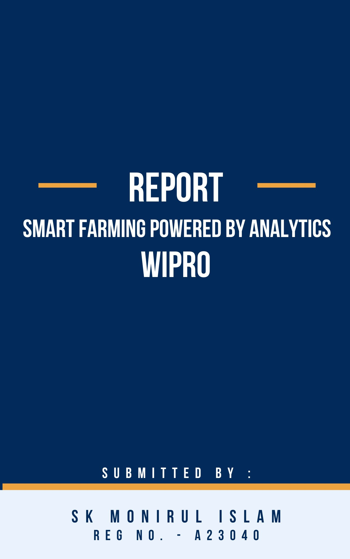 ,,,,ooooooooooooooooooooooooooo

Company Background:

Wipro Limited (NYSE: WIT, BSE: 507685, NSE: WIPRO) is a leading technology services and consulting company focused on building innovative solutions that address clients’ most complex digital transformation needs.

We leverage our holistic portfolio of capabilities in consulting, design, engineering, operations, and emerging technologies to help clients realize their boldest ambitions and build future-ready, sustainable businesses.

A company recognized globally for its comprehensive portfolio of services, strong commitment to sustainability and good corporate citizenship, we have over 245,000 dedicated employees serving clients across 65 countries.



Product 0verview :

Smart Farming refers to the application of modern Information and Communication Technologies (ICT) in agriculture. It promises to revolutionize the world of agriculture through the application of solutions such as Internet of Things(IoT), actuators and sensors, geo-positioning systems, drones or unmanned aerial vehicles(UAVs), precision equipment, robotics, etc. backed and powered by technologies such as Big Data, Analytics, and Cloud.

Smart Farming has a real potential to deliver more efficient and sustainable agricultural production, through data-driven insights and decisions, and better resource management.

From the farmer’s point of view, Smart Farming will provide the farmer the means for better decision making and more efficient operations and management. Smart farming is associated to three fields of technology, which are inter-related:

1.Management Information Systems: Systems for collecting, processing, storing, and sharing data in a suitable form to carry out a farm’s operations and functions.

2.Precision Agriculture: Management of the vagaries of weather, soil and other environmental conditions as well as demand scenarios to improve economic returns following the use of inputs and reduce environmental impact. It employs Decision Support Systems (DSS) for farm management in order to optimize returns while preserving resources. - enabled by technologies like global positioning system (GPS), global navigation satellite system (GNSS), images captured by drones or unmanned aerial vehicles, and hyperspectral images captured by satellites. This helps in the creation of maps depicting how several parameters spatially vary. (e.g. farm yield, organic matter content, soil moisture and nitrogen levels, terrain, etc.).

3.Agricultural Automation and Robotics: Another aspect of smart farming that deals with application of robotics, automatic control and artificial intelligence (AI) at various levels of agricultural production, including farm bots and farm drones.

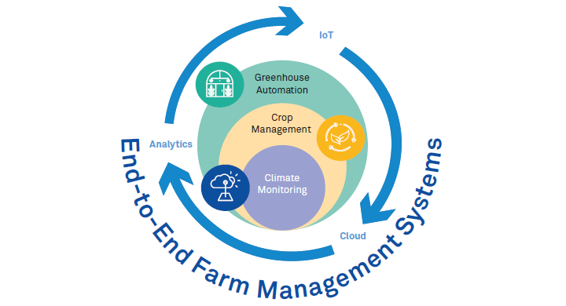

Product Value Proposition:

1. Increased Crop Yields:
2. Precision in Resource Allocation: Smart Farming removes the guesswork by providing real-time data on factors like soil moisture, nutrient levels, and weather conditions. This allows for targeted application of resources, ensuring crops receive exactly what they need at the right time. Imagine a sensor network indicating a specific area in the field is drier than others. Smart irrigation systems can then deliver water only to that dry patch, optimizing water usage and ensuring all plants have sufficient moisture for growth.
3. Improved Crop Health Monitoring: Sensor data and high-resolution imagery captured by drones can reveal early signs of stress or disease in crops. This allows for prompt intervention with targeted treatments, minimizing crop damage and preventing outbreaks from spreading. Early detection of deficiencies in specific nutrients can also be addressed with precise fertilizer application, ensuring optimal plant growth.
4. Reduced Water Usage:

Smart Farming utilizes soil moisture sensors to determine the exact water needs of crops at any given time. Irrigation systems can then be automated to deliver the precise amount of water directly to the root zone, minimizing evaporation and ensuring efficient water usage. This is particularly beneficial in drought-prone regions, where water conservation is crucial for sustainable agriculture.

1. Improved Fertilizer Application:

Traditionally, fertilizer application is often a blanket approach, spreading fertilizer uniformly across the entire field. Smart Farming employs soil testing and sensor data to identify areas with specific nutrient deficiencies. This allows for targeted fertilizer application, delivering the necessary nutrients only to the areas that need them. This not only reduces fertilizer waste but also minimizes potential environmental impact from fertilizer runoff. Imagine a sensor network indicating that the left side of your field has lower nitrogen levels compared to the right. You can then program fertilizer application equipment to deliver only the required amount of nitrogen fertilizer to the left side, optimizing nutrient delivery and reducing waste.

1. Reduced Disease and Pest Outbreaks:

Sensor data on factors like temperature, humidity, and leaf chlorophyll content can indicate potential conditions favourable for pest or disease outbreaks. Additionally, high-resolution drone imagery can help identify early signs of infestations. This allows for preventative measures like targeted pesticide application or the introduction of beneficial insects before outbreaks become widespread. Early detection and intervention significantly minimize crop damage and associated yield losses.

1. Improved Farm Labor Efficiency:

Robotic planters, self-driving tractors, and autonomous weeding machines can automate many repetitive and labour-intensive tasks. This frees up valuable time for farmers to focus on more critical aspects of farm management, such as crop planning, market analysis, and financial management. Automation can also improve the accuracy and efficiency of tasks like planting and weeding, leading to better crop establishment and reduced labour costs.

Key Product Performance Parameters:

1. Crop Yield:

Crop yield is the fundamental KPI in agriculture, reflecting the total amount of crops harvested from a specific area (e.g., tons of wheat per hectare). It's a direct indicator of agricultural productivity and a key factor in farm profitability.

1. Water Usage:

Water is a finite resource, and agriculture is a major consumer. Tracking water usage helps assess the efficiency of irrigation practices. Ideally, Smart Farming should lead to a decrease in the total amount of water used per unit of crop yield (e.g., litres of water per kilogram of grain).

1. Fertilizer Application:

Excessive fertilizer application is not only wasteful but can also contribute to environmental pollution. Tracking fertilizer application helps assess resource utilization and potential environmental impact. Smart Farming aims to optimize fertilizer application by delivering the right amount of nutrients to the right areas at the right time.

1. Disease and Pest Infestation Rates:

Disease and pest outbreaks can significantly reduce crop yields and lead to economic losses for farmers. Tracking infestation rates helps assess the effectiveness of pest and disease management strategies. Smart Farming aims to enable early detection and intervention through sensor data and drone imagery.

1. Farm Labor Productivity: Farm labor is a significant cost factor in agriculture. Tracking farm labor productivity helps assess the efficiency of farm operations. Ideally, Smart Farming should lead to an increase in output generated per unit of labor input (e.g., tons of grain harvested per hour of labor).

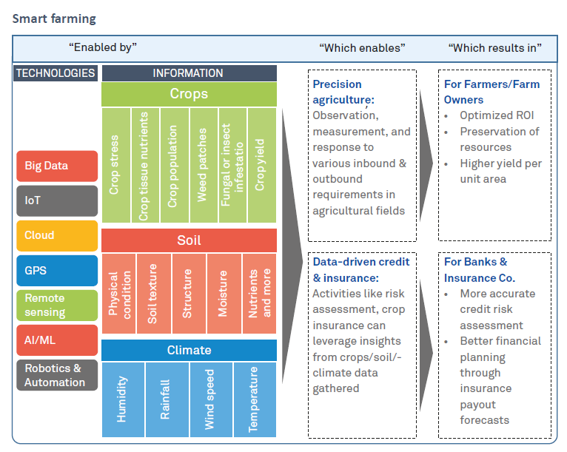

Technological Framework:

1. IoT Sensors: Tiny Powerhouses, Big Impact

These miniature devices act as the eyes and ears of the farm, constantly collecting real-time data on vital factors like soil moisture, temperature, and even plant health. This continuous data stream provides a comprehensive understanding of the farm environment.

1. Data Analytics: Transforming Data into Decisions

The raw data collected by sensors is like unmined treasure. Powerful data analytics platforms step in, using machine learning to identify trends and predict potential issues. This empowers farmers to move beyond guesswork and make informed decisions about resource allocation.

1. Precision Agriculture: Optimizing Every Drop, Every Granule

Armed with data insights, farmers can employ precision agriculture techniques. This essentially means using data to optimize resource utilization. Imagine variable rate irrigation delivering water only to thirsty areas, or targeted fertilizer application that nourishes specific needs. Precision agriculture maximizes efficiency and minimizes waste.

1. Robotics and AI: The Future of Farm Labor

While data is king, automation is the helping hand. Robotics and AI are transforming farm operations. Robots can handle repetitive tasks like planting and harvesting with incredible precision. Self-driving tractors reduce labor costs and improve efficiency, while AI-powered weed identification systems target weeds for control, minimizing herbicide use.

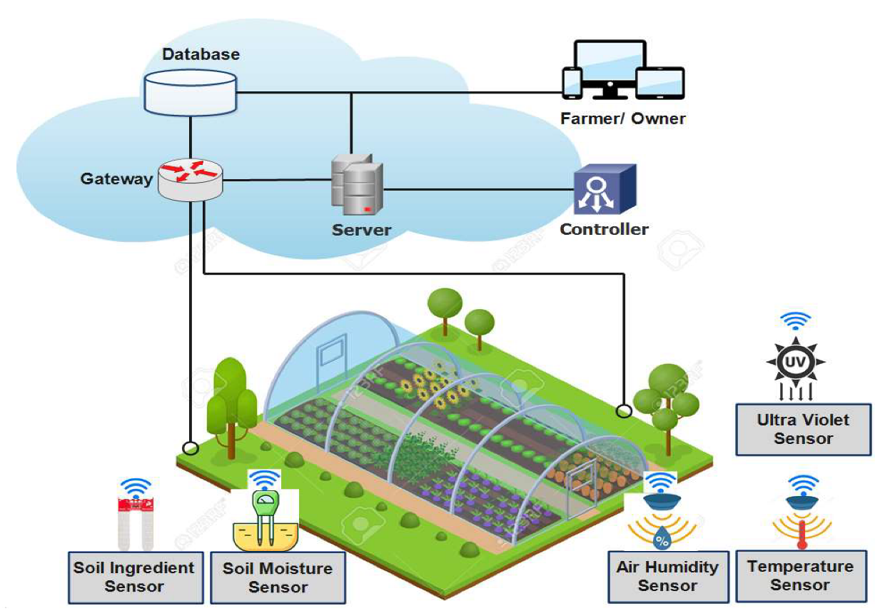

Target Consumers:

1. Large-Scale Commercial Farms: Prime Candidates for Smart Farming

Economic Advantages: Large commercial farms have the most to gain from Smart Farming due to economies of scale. The upfront investment in technology can be offset by significant gains in efficiency, yield improvement, and resource savings.

Precision is Key: Large farms often deal with diverse soil conditions and microclimates. Smart Farming allows for precise resource allocation based on real-time data, maximizing productivity across different zones within the farm.

1. Medium-Sized Farms: A Targeted Approach Can Yield Big Results

Strategic Implementation: While upfront costs might be a concern, medium-sized farms can benefit from a targeted approach. They can prioritize technologies that address their most pressing needs, such as optimizing irrigation or improving fertilizer application.

Focus on Efficiency: Smart Farming can help medium-sized farms streamline operations, reduce labor costs through automation, and improve overall farm efficiency. This can lead to increased profitability even with a moderate investment in technology.

1. Small-Scale Farms and The Future:

Technological Advancements: As Smart Farming technology becomes more affordable and accessible, even small-scale farms will be able to benefit. The development of low-cost sensor networks and cloud-based analytics platforms could make Smart Farming a viable option for smaller growers.

Collaboration and Knowledge Sharing: Small farms can explore collaborative approaches, such as sharing sensor data or equipment with neighbouring farms, to make Smart Farming solutions more cost-effective. Knowledge sharing through farmer cooperatives and government initiatives can also help bridge the technological gap for smaller farms.

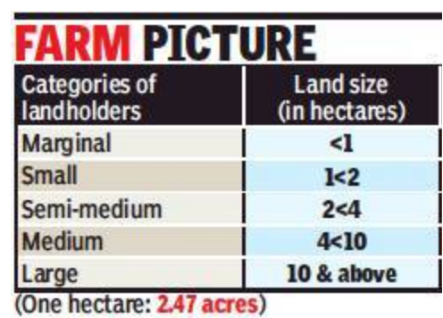

Go-to-Market Strategy:

1. Partnerships between technology companies and agricultural equipment manufacturers.
2. Direct sales to farmers by agricultural technology companies.
3. Government subsidies to encourage adoption of Smart Farming technologies.

Pricing:

1. Technology Stack: The specific sensors, data analytics platforms, automation equipment, and software involved significantly impact cost. A basic solution with essential sensors and cloud-based analytics will be less expensive than a comprehensive system with high-tech robotics and advanced AI features.
2. Farm Size and Needs: Larger farms typically require more extensive sensor networks and sophisticated data management systems, leading to higher costs. Smaller farms might opt for scaled-down solutions that focus on specific needs like irrigation optimization.
3. Deployment and Maintenance: The cost of installation, configuration, and ongoing maintenance of the Smart Farming system also factors into the pricing model. Some companies might offer bundled packages including installation and support, while others might charge separately.
4. Subscription: subscription-based services, where farmers pay a monthly or annual fee for access to the technology platform and ongoing support. Separate charges for data storage or additional features.

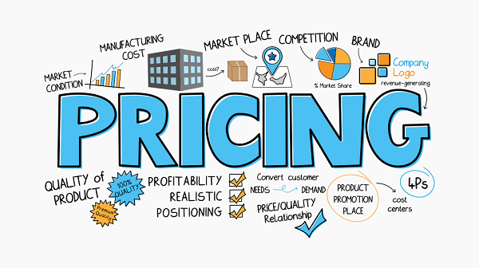

Competitive Analysis:

1. John Deere: A major player in agricultural equipment, John Deere leverages its expertise in precision agriculture technologies. They offer solutions like tractor guidance systems, yield monitors, and farm management software that integrate with existing machinery. John Deere focuses on providing a seamless experience for farmers already using their equipment.
2. Monsanto (now Bayer): A leading seed and agricultural chemicals company, Bayer (which acquired Monsanto in 2016) offers data-driven solutions for optimizing crop health and yield. Their focus lies in combining traditional breeding techniques with advanced data analytics to develop new crop varieties and targeted crop protection solutions.
3. IBM: A tech giant with a strong presence in cloud computing and analytics, IBM offers its Watson AI platform for agriculture. This platform helps farmers analyze sensor data, predict crop yields, and optimize resource use. IBM focuses on providing a comprehensive data-driven approach to farm management.
4. Microsoft: Another tech leader, Microsoft offers its Azure cloud platform to store and analyze agricultural data. They also partner with agricultural equipment manufacturers to integrate their cloud services with farm machinery. Microsoft focuses on providing the technological infrastructure for Smart Farming solutions.
5. Cropin: Cropin is a global ag-ecosystem intelligence provider. Cropin’s suite of products enables various stakeholders in the Agri-ecosystem, including financial services providers, to adopt and drive digital strategy across their agricultural operations. Using cutting-edge technology like artificial intelligence, machine learning, and remote sensing, Cropin creates an intelligent, interconnected data platform. Cropin helps organizations digitize their operations from farm to fork and leverage near real-time farm data and actionable insights to make effective decisions.

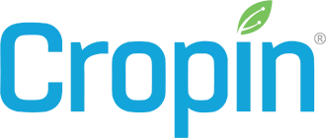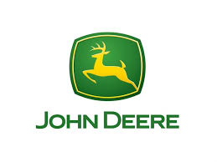

SWOT Analysis:

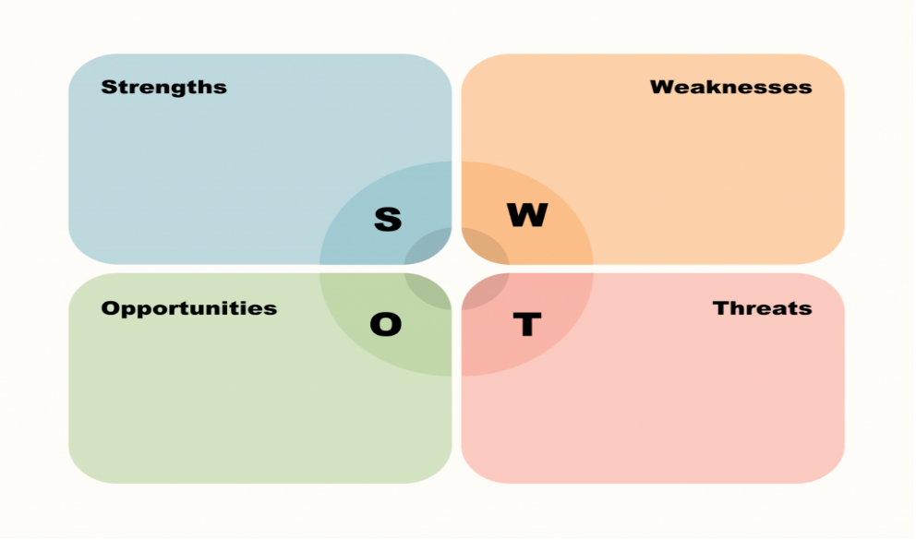

1.Strengths:

Can improve agricultural productivity and efficiency.

Can reduce water usage and environmental impact.

Can improve farm labor productivity.

2.Weaknesses:

Can be expensive to implement.

Requires farmers to have access to technology and data analysis skills.

May displace farm labor.

3.Opportunities:

Growing demand for food.

Increasing government support for sustainable agriculture.

Advancements in technology that make Smart Farming more affordable and accessible.

4.Threats:

Cybersecurity risks.

Data privacy concerns.

Lack of standardization in Smart Farming technologies.

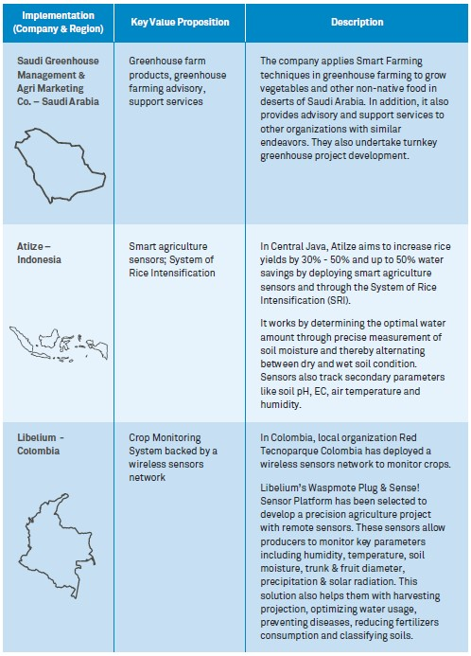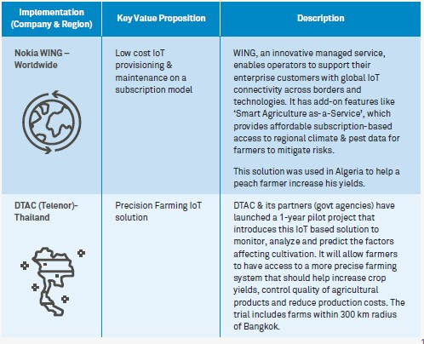Market Recognition:

Key People Behind the Project:

Debojit Biswas

Global Business Manager, Analytics & AI Consulting, Wipro

Debojit is currently working in areas of strategy, analytics, and AI consulting for a leading banking firm in the Middle East. Prior to his current engagement, as part of Wipro’s Global 100Program, he has had a diverse exposure in areas like IT delivery, pre-sales, communications domain consulting, data privacy and analytics & AI consulting. Debojit holds an MBA degree from IIMBangalore, India, and a B.Tech in Electrical &Electronics from NIT Jamshedpur, India.

Manish Sood

Consulting Partner, Analytics & AI Consulting, Wipro

Manish has more than 21 years of industry experience in Business Strategy, BusinessConsulting, Business Transformation, and DigitalTransformation. In the last decade, he has primarily consulted with clients on new digital payments product launches as well as digital transformation programs. Manish did his MBA in International Strategy and Brand Management from Goizueta Business School, Emory University, Atlanta and BE in Electronics &Telecommunication from the University of Pune, India.

